Ovariohysterectomy in Cats

What is meant by ovariohysterectomy or spaying?
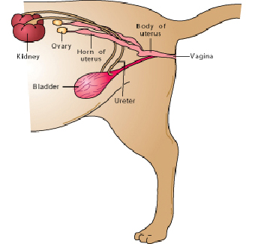
Spaying is the common term used to describe the surgical procedure known scientifically as an ovariohysterectomy. In this procedure, the ovaries and uterus are removed completely in order to sterilize a female cat.

Why should I have my cat spayed?
We recommend that all non-breeding cats be sterilized. Several health benefits are associated with spaying your cat. First, spaying eliminates the risk of ovarian and uterine cancers. Second, breast cancer is the number one type of cancer diagnosed in intact or un-spayed female cats. If your cat is spayed before her first heat cycle, there is less than ½ of 1% (0.5%) chance of developing breast cancer. With every subsequent heat cycle, the risk of developing breast cancer increases. After about 2½ years of age, ovariohysterectomy offers no protective benefit against developing breast cancer.
Finally, cats with diabetes or epilepsy should be spayed to prevent hormonal changes that may interfere with medications.

Are there other benefits to spaying my cat?
"There is no behavioral, medical or scientific reason for letting your cat have a litter before she is spayed."
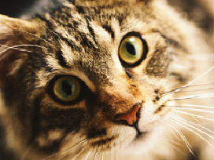
The most obvious benefit is the prevention of unplanned pregnancies. There is no behavioral, medical or scientific reason for letting your cat have a litter before she is spayed.
Once a cat reaches puberty, usually at around seven months of age, she will have a heat or estrus cycle every two to three weeks for most of the year, unless she becomes pregnant. She will be "in heat" or receptive to mating for approximately one week in each cycle. During "heat", she may display unsociable behavior such as loud and persistent crying and frequent rubbing and rolling on the floor. This behavior coupled with her scent, will attract male cats from miles around. Removal of the ovaries will stop her estrus cycles.

When should I have my cat spayed?
Spaying should be performed before the first estrus or "heat cycle". Most cats are spayed between four and six months of age although some veterinarians choose to spay cats at two to three months of age.

What does a spay surgery involve?
This major surgical procedure requires general anesthesia. You will need to fast your cat the night prior to surgery. Most cats return home within forty-eight hours after surgery. Your veterinarian will advise you how long to withhold food and water, and any other details specific to your cat.
The operation is performed through a relatively small incision made most commonly in the midline of the abdomen, just below the umbilicus. Both ovaries are removed along with the entire uterus. The surgical incision will be closed with several layers of sutures. In many cases, skin sutures will be placed, and these will be removed after seven to ten days.

Are complications common with spaying?
In general, complications are rare during an ovariohysterectomy surgery. However, as with any anesthetic or surgical procedure, there is always a small risk. The potential complications include:

Anesthetic reaction
Any individual cat can have an unexpected adverse reaction following the administration of any drug or anesthetic. Such cases are impossible to predict, but are extremely rare.
Another potential danger associated with anesthesia arises if the cat is not properly fasted prior to anesthesia. Anesthetized patients lose the normal reflex ability to swallow; during swallowing, the epiglottis, a cartilage flap at the entrance to the windpipe, closes and prevents food or water from entering the lungs. If there is food in the stomach, the cat could vomit while under anesthesia or in the early post-anesthetic period, allowing the food to enter the lungs and cause aspiration pneumonia, a potentially life-threatening condition.
Illness will increase the risks associated with anesthesia. Pre-operative blood work is a useful screening test that may detect pre-existing problems that could interfere with the pet's ability to handle anesthetic drugs.
To minimize the risks, it is important that all pre-operative instructions are strictly followed and that you report any signs of illness or previous medical conditions to your veterinarian prior to any sedation, anesthesia or surgery.
Internal bleeding
This can occur if a ligature around a blood vessel breaks or slips off after the abdomen has been closed. This is very rare, and is more likely to occur if the cat is extremely active. Clinical signs include weakness, pale gums, depression, anorexia or a distended abdomen.
Post-operative infection
This may occur internally or externally around the incision site. In most cases, the infection can be controlled with antibiotics. A post-operative infection most commonly occurs when the cat licks the site excessively or is in a damp environment.
Suture Reaction or Sinus Formation
Although extremely rare, occasionally the body will react to certain types of suture material used during surgery. This results in a draining wound or tract that may appear up to several weeks after the surgery was performed. Often a further operation is required to remove the suture material.

Will spaying have any adverse effects on my cat?
In the vast majority of cats, there are no adverse effects following an ovariohysterectomy. In certain cats, notably the Siamese breed, the hair that grows back over an operation site may be noticeably darker, believed to be due to a difference in the skin temperature. This darker patch usually grows out with the following molt as the hair is naturally replaced.
"Many myths and beliefs about spaying that are not supported by facts or research."
There are many myths and beliefs about spaying that are not supported by facts or research. Be sure to discuss any questions or concerns you may have with your veterinarian prior to surgery.

